1. Website Specifications (10 marks)
a) Website Objective & Business Goals
Website name: Quick Bites
Objective: To provide users with easy-to-follow recipes that can be prepared in 30 minutes or less, using common ingredients.
Business goals:
- Build a community of home cooks looking for quick meals.
- Establish the brand as a trusted source for simple, delicious recipes.
- Encourage repeat visits through fresh content and user engagement (contact form).
Demographic | Detail
Occupation | Students, young professionals, busy parents
Location | Urban and suburban areas.
Technical aptitude | Moderate to high comfort using:  - smartphones  - tablets  - laptops  - Familiar with browsing websites  - searching for recipes  - watching video tutorials
Age | 18 - 45 years.

C. Type of website/content
Content type: Recipe collection with step-by-step instructions, ingredient list, and food photography.
Features: responsive design, contact form for user feedback/suggestion
Tone: friendly, encouraging, and practical, "Anyone can cook."

2. Information Design and Taxonomy
Information Architecture – Site Map

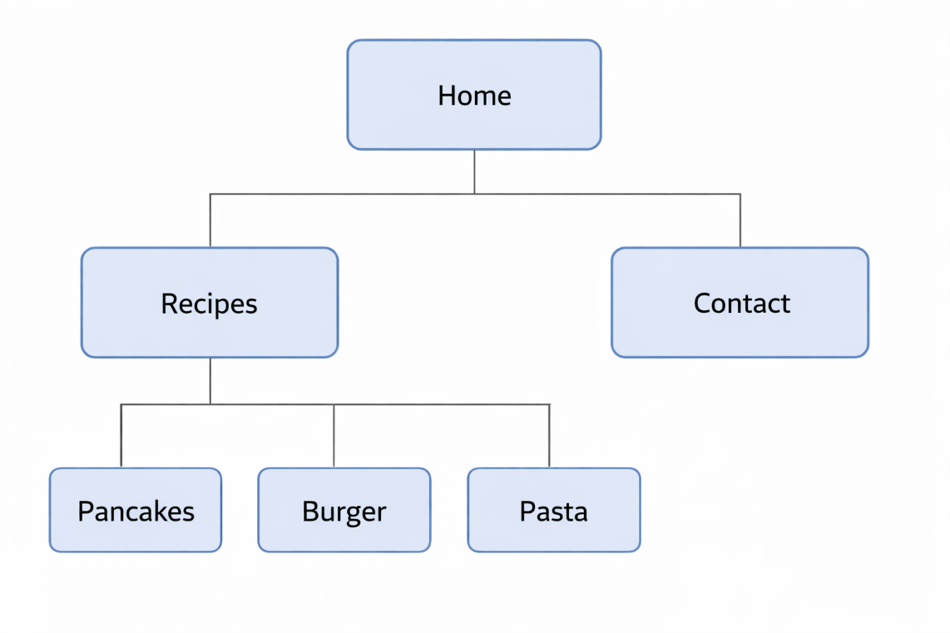

Categorization and three clicks rule
Any recipe can be reached within three clicks:
- Home
- Recipe
- Recipe of Choice
Navigation menu is present on every page: the home, recipe, and contact.

3.page template design- wireframe
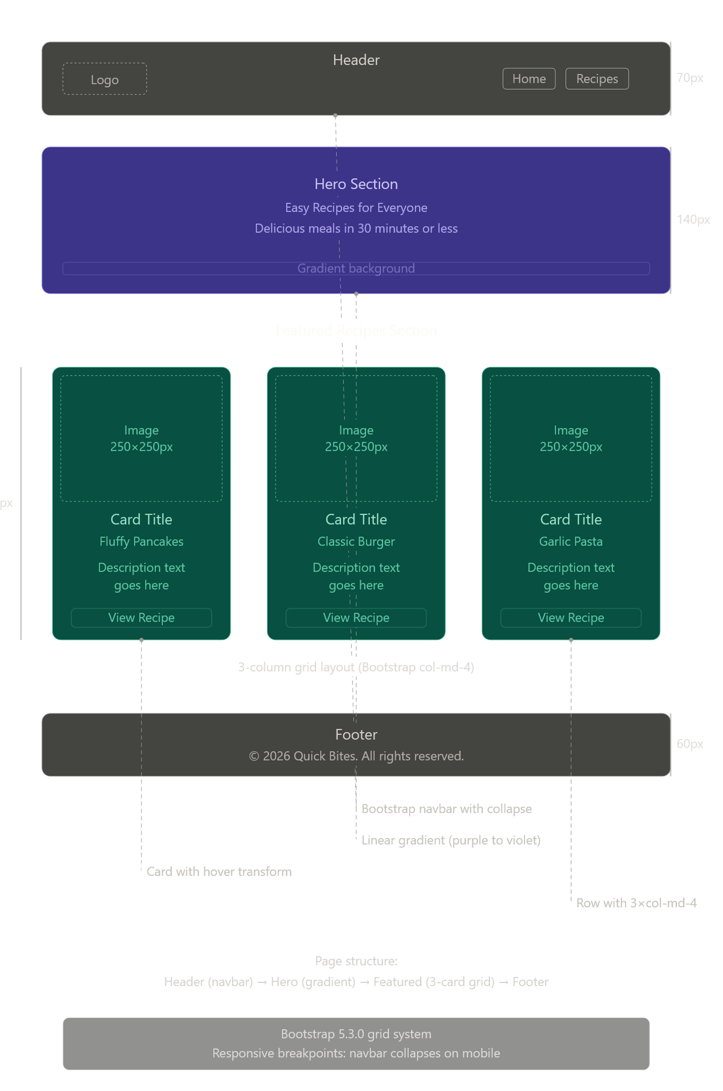
- Technical Brief
Tool/technology | Purpose
Html5 | Structural layer semantics forms images.
VS Code | Code Editor for Writing HTML/CSS
Git and GitHub | Version control and hosting: (GitHub pages)

5.Quality Assurance – Testing
Browser compatibility test
Browser | Home page. | Recipes | Contact | Form. | Results
Google Chrome | Pass. | Pass. | Pass. | Pass. | All good.
Microsoft Edge | Pass. | Pass. | Pass. | Pass. | All good.
Opera | Pass | Pass. | Pass. | Pass | All good.

Mobile device tests
Device | Screen size | Orientation
Redmi Note 10 Pro | 1080x 2400 | Portrait
Samsung Galaxy A16 | 1080x 2340 | Portraits

6.Publishing and promotion
Hosting method
The website is hosted on Github Pages, a free static hosting service.
GitHub's commands used
git init
git add.
git commit -m
git branch -M main
Git remote add origin https://github.com/cse25-428/WMD-Web-And-Multimedia-Development.git

git push – u origin main
- Future developments
To improve the website, the following enhancements are proposed:
Recipe search and filter allow users to search by ingredient, time, or difficulty.
User ratings and comments let visitors rate recipes and leave tips. Add video tutorials embedded YouTube Shorts for each recipe.

